From: https://www.theatlantic.com/politics/archive/2017/08/hillary-clinton-devotionals/535941/
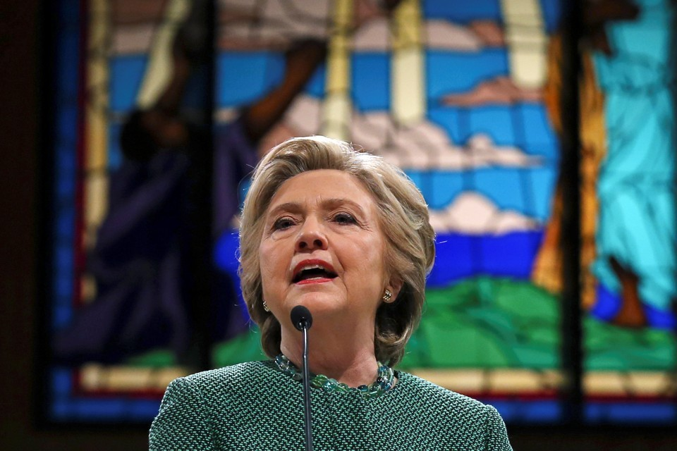
Hillary Clinton speaks at Union Baptist Church in Durham, North Carolina, in October 2016.Carlos Barria / Reuters
- EMMA GREEN

- AUG 6, 2017

TEXT SIZE

Hillary Clinton wants to preach. That’s what she told Bill Shillady, her longtime pastor, at a recent photo shoot for his new book about the daily devotionals he sent her during the 2016 campaign. Scattered bits of reporting suggest that ministry has always been a secret dream of the two-time presidential candidate: Last fall, the former Newsweek editor Kenneth Woodward revealed that Clinton told him in 1994 that she thought “all the time” about becoming an ordained Methodist minister. She asked him not to write about it, though: “It will make me seem much too pious.” The incident perfectly captures Clinton’s long campaign to modulate—and sometimes obscure—expressions of her faith.
Now, as Clinton works to rehabilitate her public image and figure out the next steps after her brutal November loss, religion is taking a central role. After long months of struggling to persuade Americans that she is trustworthy, authentic, and fundamentally moral, Clinton is lifting up an intimate, closely guarded part of herself. There are no more voters left to lose. In sharing her faith, perhaps Clinton sees something left to win, whether political or personal.

RELATED STORY
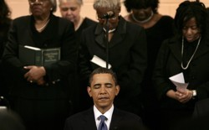
Democrats Have a Religion Problem
Two books are slated to come out of Clinton world early this fall: What Happened, Clinton’s personal account of the election, and Strong for a Moment Like This, Shillady’s book of devotionals. Shillady, who runs the United Methodist City Society in New York, wrote the book at Clinton’s suggestion; he said his is the only book for which Clinton has agreed to write a foreword. Clinton and her staffers read and approved the copy ahead of time.
Strong for a Moment Like This emerges from a project Shillady started shortly after Clinton said she was running for president in 2015. Every morning, he would get up at 4 a.m. to pick out a bit of Scripture and write a quick devotional for Clinton to use in the day ahead. Sometimes, he asked fellow pastors to contribute a devotional to the project, including the more than 100 women clergy who formed a group called “We Pray with Her.” Shillady includes bits of his email correspondence with Clinton, such as her delight at a new prayer or parable, or thank-you notes following get-togethers with Methodist clergy. Sometimes, Shillady said, he would get a call from Clinton’s chief speechwriter, Dan Schwerin, who wanted to work something from the day’s devotional into his boss’s remarks. In her concession speech, Clinton quoted a verse from Galatians: “Let us not grow weary in doing good, for in due season, we shall reap if we do not lose heart.” Shillady had sent her that verse in a devotional a few weeks earlier, he said.
The book offers a rare window into the way Scripture appears to have shaped Clinton on the campaign trail—as it has throughout her life. Hillary Rodham grew up attending First United Methodist Church in the conservative suburb of Park Ridge, Illinois, often taking field trips into Chicago with her youth pastor to see figures like Martin Luther King Jr. While other girls were flipping through beauty mags, she was reading about Vietnam and poverty in a now-defunct magazine for Methodist students called motive. (The title was always styled with a lower-case m.)
Clinton brought her faith with her as she entered political life, in times both good and bad. During the Clinton administration, the family attended Foundry United Methodist Church in Washington, D.C. Mike McCurry, who served as Bill Clinton’s press secretary during the early Monica Lewinsky years and now teaches at Wesley Theological Seminary, told me “her faith and her ability to think about forgiveness … was a very, very important part of how she dealt with that family crisis.” A well-worn Bible was always on the Clinton family’s dining room table during that time, he said.
Strong for a Moment Like This suggests Clinton was thinking about biblical themes throughout 2015 and 2016, as well. The title is drawn from the Book of Esther, which tells the story of a young woman who must stand up to corrupt political figures in order to save her people. The female clergy who contributed to the book seemed particularly preoccupied with the strong women of the Bible: Esther makes a number of appearances in their devotionals, as do Shifra and Puah, the midwives who covertly save Moses from death in the Book of Exodus. Shillady said Clinton particularly enjoyed stories about women and female voices.
Yet early in her career, Clinton learned the dangers of speaking publicly about her religious beliefs. When she was First Lady, progressives roundly mocked her moralism, and conservatives doubted her sincerity. After getting widely panned for a speech about America’s “crisis of meaning” in 1993, Clinton waited nearly a year to talk about spirituality again—and did so, she said, “with some trepidation.”
On the campaign trail, Clinton would talk about prayer or witness her faith when asked, and spoke about religion when she visited black churches. But she largely relied on secular terms. One of her favorite expressions was, “Do all the good you can, by all the means you can”—a phrase often misattributed to the founder of Methodism, John Wesley, that might not sound religious to those who don’t know the history. Clinton did not revive her decades-old rhetoric about “spiritual renewal” and “[filling] that sense of emptiness with the Word.” Instead, she spoke neutrally about kindness, love, and respect. “Hillary finds it hard to talk about religion a lot,” McCurry said. She “comes from the Methodist tradition, which, like many more liberal, mainstream Protestant denominations, is a little more buttoned up.”
Her move may have been strategic, but it also may have cost her. As primary season approached last year, nearly half of Americans described Clinton as not very or at all religious or said they didn’t know what her religion was. The conservative commentator Erick Erickson pointed out that some leaders were more willing to believe Trump is a Christian “without ever professing Jesus as his Lord and Savior” than they were to believe Clinton’s stated faith in the gospel.
The big swing states that Clinton lost in November—Pennsylvania, Wisconsin, Michigan—are strongholds of white, working-class voters, many of whom are mainline Protestants and Catholics. Clinton did not focus on faith outreach to these groups: Her campaign declined a speaking invitation at Notre Dame, for example, reasoning that white Catholics weren’t her target audience.
“The challenge was a little less with the campaign and more with the progressive infrastructure,” said Joshua DuBois, who led faith outreach for the 2008 Obama campaign and served as the head of Obama’s Office of Faith Based and Neighborhood Partnerships. He wrote his own version of Shillady’s book in 2013, about “the daily readings that inspired President Obama.” Clinton’s supporters “too often felt like there had to be a binary choice between engaging religious Americans and Secretary Clinton being a strong progressive,” DuBois said. He was skeptical that reaching out to religious groups would have changed the outcome of the election, but “could Secretary Clinton potentially have gained a few more votes on the margins by having some Catholics events in Michigan or Wisconsin, or evangelical round tables in those places?” he said. “Perhaps.”
Shillady said Clinton could have talked about her faith more during the campaign, but largely blamed commentators for ignoring that aspect of her identity. “It’s been there all along,” he said. “The general public didn’t necessarily want to accept the fact that she’s a Christian because there’s so many critics out there about the Clintons.” Kristin Du Mez, a professor at Calvin College who is working on a book about Clinton’s faith, agreed. “When I would hear Hillary speak, knowing that she was a Methodist, I just heard so many resonances—about education, about women’s rights, about the importance of community,” she said. “Because of that, it was just baffling to me that so many other Americans not only didn’t know she was Methodist, but didn’t accept that she was Christian.”
Clinton might argue that her politics were the ultimate expression of her faith. Methodists helped lead the early 19th-century Social Gospel movement, a faith-based campaign for greater aid to the poor and vulnerable. “Historically, Methodists have been very comfortable talking about policy issues in terms of their faith,” said Heath Carter, a professor at Valparaiso University in Indiana. But “for them … it’s possible to talk about the reasons why you might support a policy without specifically citing theological doctrines.” As Shillady put it, Clinton “doesn’t wear her religion on her sleeve, she just practices it. She follows the edict of what’s attributed to St. Francis: ‘Preach the gospel always, and if you need to, use words.’”
Shillady insists his book is not intended to be political. “It’s an inspirational book,” he said. “I do not believe that she encouraged me to write this book in any way to change the image of her. She really found [the devotionals] so helpful to her in the midst of the contentious campaign that she felt that people would find some hope … from it.” Perhaps it’s inspirational literature fit for an age of toxic partisanship: Tucked among the passages on hope, blessings, and prayer are subtle shots at Trump, like a tweet bragging about his court defeats on the travel ban or a call for him to step up and condemn the wave of bomb threats against Jewish Community Centers earlier this year. Shillady paraphrased the theologian Karl Barth, saying he wrote with “a newspaper in one hand and the Bible in the other”; he wanted to show that he was crafting the devotionals in response to current events. But many of the news clippings and tweets peppered in the margins date from after the conclusion of the project. They seem carefully curated to vindicate not just Clinton’s faithfulness, but her political record as well.
Once a politician has spent as many years in the public eye as Clinton has, always trailed by a faint cloud of real or imagined scandal, it becomes impossible to distinguish the authentic from the tightly controlled public image. It’s ironic that Clinton has chosen this period in her life—on the heels of failure, fading out of public life—to celebrate a part of herself that she cherishes, just as millions of other Americans cherish their faith. Perhaps, after being unwilling to wield her faith as a voter-recruitment tool, she’s willing to sacrifice her privacy in a final bid for public redemption.
Or perhaps she is settling into an alternate path, one she’s apparently fantasized about in secret for a long time.
“Given her depth of knowledge of the Bible and her experience of caring for people and loving people, she’d make a great pastor,” Shillady told me. No, she probably won’t go to seminary, he said. No, she probably won’t pursue an official lay position in the Methodist church, like deaconess. (I reached out to Clinton’s spokespeople for comment, but didn’t hear back.) “I think it would be more of … her guest preaching at some point,” he said. “We have a long history of lay preachers in the United Methodist Church.”
Since the election, “I think her faith is stronger,” Shillady added. “I haven’t noticed anything different, except that I think she is more relaxed than I’ve ever seen her.” Maybe after all these years of hard-scrabble politics, Clinton is finally becoming a more straightforward version of herself: a woman whose fondest ambition is teaching scripture in church.

From: https://ibankcoin.com/#sthash.JbD9pSD9.qOOe5TrI.dpbs OR http://ibankcoin.com/zeropointnow/2017/08/08/hillary-goes-from-seances-and-spiritcooks-to-bible-thumping-for-votes/#sthash.zO0QQ9ne.dpbs

'Aspiring Pastor' Hillary Goes From Seances And SpiritCooks To Bible Thumping For Votes

zeropointnow Tue Aug 8, 2017 11:54am EST 9 Comments
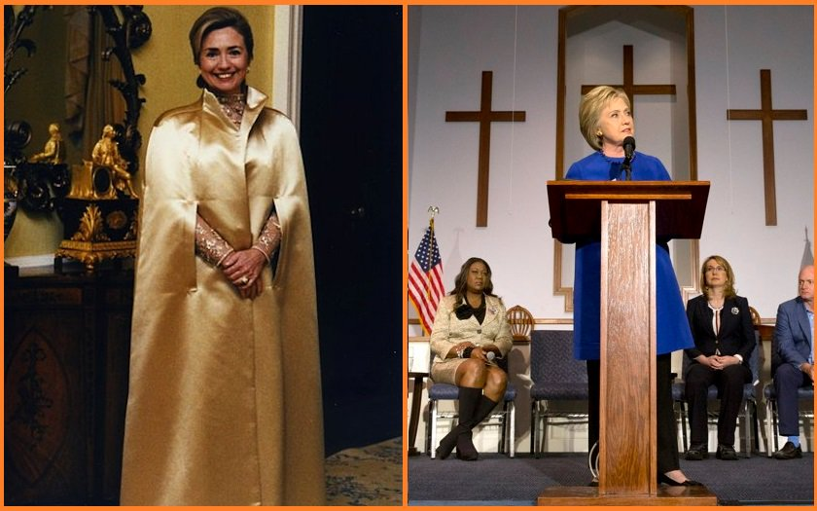
According to deep state’s department of brand management & optics Atlantic division, the ever-pious Hillary Clinton wants to become a pastor – a move which is sure to bring religious rust-belt swing voters back to the blue side for any future political endeavors…
“Hillary Clinton wants to preach. That’s what she told Bill Shillady, her longtime pastor, at a recent photo shoot for his new book about the daily devotionals he sent her during the 2016 campaign. Scattered bits of reporting suggest that ministry has always been a secret dream of the two-time presidential candidate: Last fall, the former Newsweek editor Kenneth Woodward revealed that Clinton told him in 1994 that she thought “all the time” about becoming an ordained Methodist minister. She asked him not to write about it, though: “It will make me seem much too pious.” The incident perfectly captures Clinton’s long campaign to modulate—and sometimes obscure—expressions of her faith.” –The Atlantic
Because what better way to make people forget about a massive pay-for-play scheme, raping Haiti, and a bitchy image than God?
Seances
While Hillary has apparently been in the closet for decades over her desire to preach, she turned heads in the 90’s when investigative journalist Bob Woodward wrote in his book ‘The Choice,” that Clinton “held imaginary conversations with Eleanor Roosevelt and Mahatma Ghandi as therapeutic release.” When an advisor suggested that she communicate with Jesus Christ, she declined, saying it would be “too personal.”
Satanic Idols
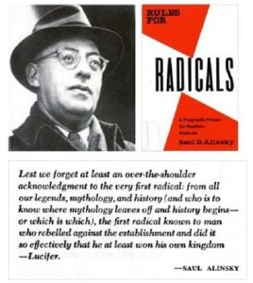In 1993, the president of Wellesley College approved a new rule that all senior theses written by a president or first lady of the United States would be kept under lock and key, a move aimed at preventing the public from learning about their new First Lady. After the Clintons left the White House, however, Hillary’s senior thesis was released to the public – a 92 page homage to radical leftist Saul Alinsky, who dedicated his book to Lucifer.
Hillary describes Alinsky as a “neo-Hobbesian who objects to the conventional mystique surrounding political processes; for him, conflict is the route to power.”
Kind of like Satan, or Jihad.
That’s the spirit!
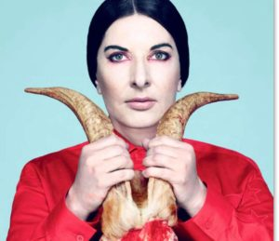I’m sure you remember #Spiritcooking satanist Marina Abramovic from 2016 election Wikileaks – who Tony Podesta gave money to, who was invited to Hillary Clinton’s Campaign launch, whose art Hillary Clinton placed in US embassies around the world, who Hillary wanted to invite to a lunch event, who donated the maximum $2700 to Hillary’s campaign, and who said in a Reddit AMA (“Ask Me Anything”) that her spirit cooking dinners in private homes are not art.
I think it’s safe to say that Hillary Clinton is a fan of Marina Abramovic, whose ‘art’ probably wouldn’t go over so well with the Methodist congregation Hillary apparently wants to preach to.
While Hillary’s base is sure to lap up her new ‘revelation’ about her faith, the rest of us aren’t buying it…
What will they cook up next?
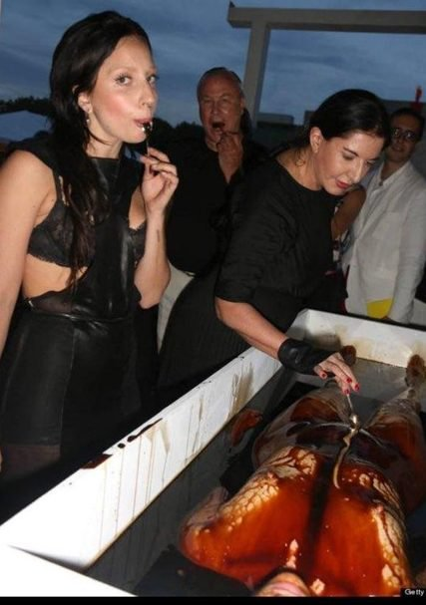

Jeff Sessions Blocks Joe Biden From Touching His Granddaughter

https://www.youtube.com/watch?v=QtkA7ghayJM

From: https://medium.com/indian-thoughts/hillary-clinton-continues-to-assure-america-that-it-made-the-right-choice-47180ac0f166
Caitlin Johnstone
Rogue Journalist
Jun 1, 2017

Hillary Clinton Continues To Assure America That It Made The Right Choice
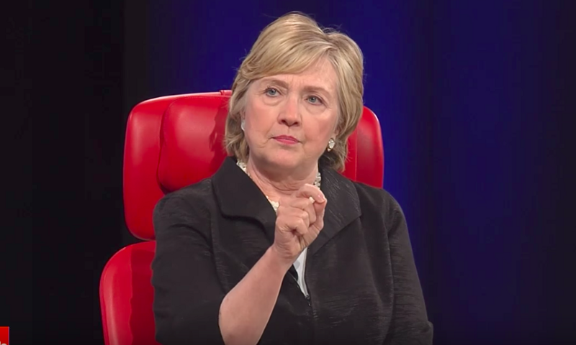
I don’t understand why everyone’s so hard on Hillary Clinton, personally. This great woman has accomplished so much, from being married to Bill Clinton to collapsing the nation of Libya, and here she is creating space in her busy schedule of drinking champagne, assaulting her house servants and masturbating to classified footage of Saudi war crimes to reassure her country that it made the right choice in November. All out of the goodness of her own heart.
Here is an actual, real-life, nonfiction excerpt from the transcript of Clinton’s interview at the 2017 Code Conference yesterday, which I swear I am not making up:
“And there have been some studies done since the election that if you look — let’s pick Facebook. If you look at Facebook, the vast majority of the news items posted were fake. They were connected to, as we now know, the 1,000 Russian agents who were involved in delivering those messages.”
In addition to whatever that was, Clinton also repeated the now fully debunked lie she’s been spreading since October that “seventeen agencies” in the US intelligence community had agreed Russia was to blame for the WikiLeaks releases in the last election cycle, argued that Russia couldn’t have known how to run a propaganda campaign in the United States without insider information from the Trump camp, and blamed her loss on James Comey, treason, misogyny, “weaponized information”, Russia and Wikileaks (which she continues to assert are the “same thing”), fake news, the alternative media, the mainstream media, the right-wing media, social media, the New York Times (yes, that New York Times), the DNC (yes, thatDNC), the Supreme Court ruling on the Voting Rights Act, unreasonably high expectations that she would win, the Mercers, and bots.
“I take responsibility for every decision I made, but that’s not why I lost,” Clinton said.
And there you have it: clear, unequivocal reassurance that the American people did the right thing by refusing to hand that woman the keys to the most powerful military force in the history of civilization. Obviously someone who can’t even take personal responsibility for a poorly-run political campaign would never accept personal responsibility for the lives lost due to any use of the unfathomable killing power she’d have been granted as Commander-in-Chief of the United States.
Can you imagine that total lack of accountability dancing with the power to invade sovereign nations, topple governments, and deploy nuclear weapons?
“Madame President, what happened to the Philippines???”
“Breitbart and Infowars are using weaponized information.”
“But you just carpet-bombed Manila!”
“Umm… Putin?”
This is the same woman who laughed at Gaddafi’s horrific death after the rape of Libya she herself spearheaded, mind you. The woman who wanted to install a no-fly zone in Syria despite top generals warning that this could lead to war with both Syria and Russia. The woman throughout her entire political career has been pushing for disastrous war blunder after disastrous war blunder seemingly at every opportunity, who both loves war and sucks at it. This woman, who continues to demonstrate a complete lack of any personal responsibility for any of her actions, asked the American people to trust her to use the incomparable military power of a US President responsibly.
And that’s on top of, you know, the lying. I know we’ve all been very polite until now about Hillary’s propensity for making stats up on the fly but really, Hills, seventeen intelligence agencies you say? Russia is the “same thing” as WikiLeaks? Well, I’ll be.
Someone who lies, who can’t take responsibility, who blames “fake news” for everything she doesn’t like, who makes hilariously conspiratorial-sounding statements like the “Russian WikiLeaks” nonsense she pulled out of her hoo-ha — does that not sound like another certain 2016 presidential candidate? Hillary would have been Trump with a vagina but without all the eyes on her. Trump but with a complicit media who happily make the case for her alternative facts being true. Trump but with a lust for blood and war.
Americans were given a horrible choice between two historically awful candidates, and they chose the lesser of two evils. We were told that if Trump was elected America would be either a smouldering crater or a goose-stepping fascist dystopia where Muslims are kept in concentration camps by now, and yet seven months later the US is still pretty much the same everyday corporatist bullshit factory Obama left it. We’re all still praying for a miracle to save us from the ecocidal, omnicidal trajectory America’s unelected power establishment has had our planet on, but at least we’re still in the fight. That is likely a lot more than you‘d have been able to say for a war-loving, Russia-hating strategical imbecile with no sense of responsibility for her own behavior.
The mass media machine is trying to force Americans to swallow the belief that they made the wrong choice in November, and that next time they’d better be more obedient and listen to the talking heads on TV. These people are lying, and they are wrong. There is no longer any valid reason to continue settling for this planet-killing oligarchic trajectory any longer. Keeping Hillary out of the White House was a good first step, but it was only a first step, the first of many necessary steps we’ll need to take to turn this thing around and prevent environmental catastrophe or nuclear war.


Caitlin Johnstone
Rogue Journalist

